**TOPIC**

**FACTORS AFFECTING LIQUIDITY RISK OF 28 COMMERCIAL BANKS IN VIET NAM FROM 2011 TO 2021**

Student: Nguyen Thi Ai Nhi

Ho Chi Minh - 2022

**ABSTRACT SUMMARY**

The topic name: Factors affecting liquidity risk of 28 commercial banks in Vietnam from 2011-2021. The main objective of this study is to identify characteristics that clarify liquidity risk of Vietnamese commercial banks. Observation data was collected from 28 commercial banks from 2011-2021, including Size of the bank (SIZE); Loan Loss Provision (LLP); Return on Equity (ROE); Capital Adequacy Ratio (CAR); Loan to Total Asset Ratio (LTA); Bank’s equity ratio - Equity/Total Assets (ETA); Economic Growth Rate (GDP) and Inflation rate (INF).

The content of the research includes the following contents: Firstly, the presence of the study comes from the requirements of Vietnamese commercial banks to limit liquidity risk in the context of increasingly fierce competition among banks. Secondly, the study takes data from existing domestic and international studies in order to identify factors affecting liquidity risk to serve as a theoretical foundation and inherit research models. Thirdly, the source of research data is collected from the financial statements of 28 Vietnamese commercial banks from 2011 to 2021. Fourthly, the author uses a variety of qualitative methods (description, comparison, analysis) to quantitative methods (Pooled OLS, FEM, REM, FGLS and GMM) used specifically for panel data regression in the study. Finally, the analysis, observations and conclusions are all based on research results, and the author's recommendations are made to avoid liquidity risks in banking activities. The author assumes that this study will serve as a future reference and that the results of the study will be of value to bank administrators, legislators, and other scholars.

**TABLE OF CONTENT**

LIST OF GRAPHICS 6

CHAPTER 1.      INTRODUCTION 7

*1.1.  Research motivations: 7*

*1.2.  Research objectives: 7*

*1.2.1.   General objective: 7*

*1.2.2.   Specific objective: 7*

*1.3.  Research questions: 8*

*1.4.  Subject and scope of the study: 8*

*1.4.1.   Subject of the study: 8*

*1.4.2.   Scope of the study: 8*

*1.5.  Contribution of research: 8*

CHAPTER 2.      LIQUIDITY RISKS AND MEASUREMENT 9

*2.1.  The concept of liquidity risk 9*

*2.2.  Factor affecting  liquidity risk 9*

*2.2.1.   Bank – specific factors 9*

*2.2.2.   Macroeconomic factors 12*

CHAPTER 3.      RESEARCH MODEL AND METHOD 15

*3.1.  Research model 15*

*3.2.  Measurement of research variables 15*

*3.2.1.   Size (Size of the bank) 15*

*3.2.2.   LLP (Loan Loss Provision) 16*

*3.2.3.   NIM (Net Interest Margin) 16*

*3.2.4.   ROE (Return on Equity) 16*

*3.2.5.   CAR (Capital Adequacy Ratio) 16*

*3.2.6.   LTA (Loans to Total Asset Ratio) 16*

*3.2.7.   ETA (Equity to Asset Ratio) 16*

*3.2.8.   GDP (Economic Growth Rate) 16*

*3.2.9.   INF (Inflation rate) 17*

*3.3.  Research hypothesis 17*

*3.3.1.  Size 17*

*3.3.2.  LLP 17*

*3.3.3.  ROE 17*

*3.3.4.  CAR 18*

*3.3.5.  LTA 18*

*3.3.6.  ETA 18*

*3.3.7.  NIM 18*

*3.3.8.  GDP 19*

*3.3.9.  INF 19*

CHAPTER 4.      ANALYSIS AND RESEARCH DISCUSSION 21

*4.1.  Descriptive statistical analysis 21*

*4.2.  Correlation analysis 23*

*4.3.  Estimating the regression model and testing the regression hypotheses 25*

*4.3.1.  Compare Pooled model – OLS and Fixed Effect Model (FEM) 25*

*4.3.2.   Compare Pooled model – OLS and REM 26*

*4.3.3.  Compare FEM and REM 27*

*4.3.4.  Check for multicollinearity 27*

*4.3.5.  Check for autocorrelation 28*

*4.3.6.  Test for the phenomenon of autocovariance change 29*

*4.3.7. Check for stationary 29*

*4.3.8. Check for heteroskedastic 31*

*4.4.  Overcoming the research model and GMM regression method 31*

*4.4.1.  Overcoming the research model 31*

*4.4.2. GMM Regression Model Method 36*

*4.4.3.  Summarize and discuss research result 37*

CHAPTER 5.      CONCLUSION, RECOMMENDATION AND LIMITATION OF RESEARCH MODEL 42

*5.1.  Conclusion 42*

*5.2.  Recommendation 42*

*5.3.  Limitation 43*

REFERENCES 44

**LIST OF ACRONYMS**

|  |  |  |
| --- | --- | --- |
| **No.** | **Acronym** | **Meaning** |
| 1 | OLS | Pooled OLS regression model |
| 2 | FEM | Fixed Effects Model |
| 3 | REM | Random Effect Model |
| 4 | FGLS | Feasible generalized least squares model |
| 5 | GMM | Generalized Method of Moments |

**LIST OF TABLES**

*Table 1. Statistics of expected signs of variables 18*

*Table 2. Statistics of variables 21*

*Table 3. Correlation coefficients between research variables model 23*

*Table 4. Summarize of result models included OLS - FEM - REM 25*

*Table 5. F-test 25*

*Table 6. xttest 26*

*Table 7. Hausman test 26*

*Table 8. Research of multicollinearity test 27*

*Table 9. Wooldridge test 28*

*Table 10. Modified Wald test result 28*

*Table 11. Summarize research model included OLS-FEM-REM-FGLS 31*

*Table 12. GMM Regression Model 36*

*Table 13. Summarize 5 research 37*

# **LIST OF GRAPHICS**

***Graph 4.1.*** *Relationship between NIM and LA 38*

***Graph 4.2.*** *Relationship between LA and ROE 39*

***Graph 4.3.*** *Relationship between LA and LTA 40*

***Graph 4.4.*** *Relationship between LA and INF 41*

***Graph 4.5.*** *Relationship between LA and SIZE 52*

***Graph 4.6.*** *Relationship between LA and LLP 53*

***Graph 4.7****. Relationship between LA and GDP 54*

# **CHAPTER 1.**      **INTRODUCTION**

## **1.1.**  **Research motivations:**

Liquidity risk management is a challenging task for financial intermediaries like banks, so liquidity risk is the most risk as it can affect other risks. When one bank experiences a liquidity problem, the liquidity risk can spread to other banks, over time this impact affects other banks and the domestic or international banking system. Liquidity is the ability of a financial intermediary or bank to maintain a certain balance at all times by efficiently managing the inflow and outflow of money and when there is no match between the supply and demand for capital will create liquidity risk. The gap between a fund's supply and demand is known as its net liquidity position. Banks should carefully maintain this position to avoid capital shortage and liquidity risk. Banks should carefully plan their net liquidity position because when banks have liquidity problems, this damages their reputation and reliability. Banks mainly focus on liquidity management of assets and liabilities to maintain liquidity and avoid liquidity outflows. There is a trade-off between maintaining liquidity and making a profit. Keeping too much liquidity can reduce investment opportunities and adversely affect returns. On the other hand, holding less liquidity will create liquidity risk and affect the bank's growth in the long term, more seriously, increase liquidity risk. Therefore, banks need to effectively allocate and use available capital to hedge against liquidity risks. With the topic "Factors affecting liquidity risk", the author will study the factors affecting liquidity risk of Vietnamese commercial banks, thereby proposing solutions to limit liquidity risks.

## **1.2.**  **Research objectives:**

### **1.2.1.**   **General objective:**

The overall objective of this research is to determine and analyze the factors affecting the liquidity risk of Vietnamese commercial banks.

### **1.2.2.**   **Specific objective:**

 Identify and analyze the factors affecting the liquidity risk of Vietnamese commercial banks.

 Determine the level and direction of the effect of the factors on the liquidity risk of Vietnamese commercial banks.

 Build a more suitable research model based on theoretical foundations and previous studies.

 Propose appropriate solutions and recommendations to improve the liquidity effectiveness of banks and improve operational efficiency of Vietnamese commercial banks.

## **1.3.**  **Research questions:**

To achieve the stated objective, the research is carried to find answers for the following questions listed here in below:

● What factors affect the liquidity risk of Vietnamese commercial banks?

● With the above factors, how have they affected the liquidity risk of Vietnamese commercial banks?

● What is the direction of influence of the above factors on the liquidity risk of commercial banks in Vietnam?

● Based on previous studies, which research model and research methods are used to measure liquidity risk of Vietnamese commercial banks?

● What is the solution to improve liquidity risk of Vietnamese commercial banks?

## **1.4.**  **Subject and scope of the study:**

### **1.4.1.**   **Subject of the study:**

The research object of the essay is the factors affecting the liquidity risk of Vietnamese commercial banks

### **1.4.2.**   **Scope of the study:**

Scope of spatial research: The research was carried out based on the financial statements collected from 28 Vietnamese commercial banks.

Scope of time research: The research was carried out based on data collected from 2010 to 2021.

## **1.5.**  **Contribution of research:**

Theoretically, the study enhances the building of a research model on liquidity risk of Vietnamese commercial banks. Based on the most up-to-date database of banks' operations   and appropriately selected research models, the study will show the importance of building a sound liquidity system.

In practical terms, the research results of the study can be considered as a source of reference, a policy suggestion to help bank administrators and state management agencies assess liquidity risk. Along with that is the scientific basis for scholars, administrators, policymakers, etc to propose appropriate policies to improve the efficiency of banking operations, reduce risks, and improve liquidity for commercial banking system in Vietnam.

# **CHAPTER 2.**      **LIQUIDITY RISKS AND MEASUREMENT**

## **2.1.**  **The concept of liquidity risk**

There have been many different definitions of liquidity risk. But liquidity risk can be understood as the risk when commercial banks are not able to pay at a certain time or have to mobilize capital sources at high costs to meet the demand to meet payment needs; or due to other subjective reasons cause the insolvency of commercial banks, which will lead to undesirable consequences. (Duttweiler, 2009).

Banks' main functions are receiving deposits, granting loans, meeting customer obligations of payment, transfer of goods and services banks face severe liquidity risk. Liquidity risk is a multidimensional and complex issue for the banking industry. Many internal factors amplify their influence on liquidity risk. However, they can be managed by the bank and the macroeconomic factors that affect liquidity risk are therefore not controllable and their impact on liquidity risk.

Banks face liquidity risk due to their position as financial intermediaries, which convert customers' short-term deposits into long-term loans. As stated by Sopan and Dutta ( 2018 ), liquidity problems also arise due to the depositor's decision to withdraw the deposit; so the bank doesn't have enough cash to use. When creating an imbalance between financial inflows and outflows, banks find it difficult to secure additional capital, either by increasing liabilities or by returning assets immediately at a reasonable cost. affects the profitability of the bank. Liquidity risk has both a positive and a negative relationship with banks, which has been emphasized in previous studies. The negative effects of liquidity risk on bank performance are supported by previous studies such as Falconer (2001), Diamond and Rajan (2005), Zheng and Sheng (2008). Kosmidou et al . , (2008) . Arif and Anees (2012) and Alzorqan ( 2014 ) . Some studies have been found. positive effects of liquidity risk on bank performance, such as Bourke ( 1989 ), Molyneux and Thornton ( 1992 ), Berger ( 1995 ), Demirguc - Kunt et al . , ( 1998 ), Barth et al . , ( 2003 ), and Abor ( 2005 )

## **2.2.**  **Factor affecting  liquidity risk**

### **2.2.1.**   **Bank – specific factors**

● ***Liquidity asset ratio (la)***

According to previous studies (Bonfim and Kim, 2014; Bunda and Desquilbet, 2008; Delécha et al., 2012; Lucchetta, 2007; Vodova, 2011, Ferrouhi, 2014). This ratio provides general information about a bank's liquidity. That is, in the total assets of the bank, what is the proportion of liquid assets. This ratio is high, meaning the liquidity of the bank is very good.

● ***Size of bank (size)***

A commonly applied solution to measure the factors that represent bank size is log (total assets) as studied by (Williams, 2014; Abdullah and Khan, 2012; Bonfim and Kim, 2014; Delécha et al., 2012; Ferrouhi and Lahadiri, 2014; Lucchetta, 2007; Vodova, 2011). Theoretically, the larger the total assets of the bank, the less liquidity risk is exposed because the large bank can rely on the interbank market or liquidity support from the lender of last resort.

Most studies (Abdullah and Khan, 2012; Bonfim and Kim, 2014; Delécha et al., 2012; Dinger, 2009; Lucchetta, 2007; Giannotti et al., 2010) show that bank size is negatively related to liquidity risk.

● ***The loan loss provisions to loans ratio (llp)***

Provision expense for credit risk to total outstanding balance (llp) is also used to test the impact on liquidity risk. Provisions for credit losses represent a bank's level of credit risk (Chung-Hua Shen et al., 2009). Credit risk in turn impacts profitability and liquidity risk. The higher the bank's cost for credit risk provisions, the higher the liquidity risk. Therefore, we expect a positive relationship between LLP and liquidity risk.

● ***Net Interest Margins (nim)***

NIM indicates that banks with high levels of illiquid assets in loans may receive higher interest income than banks with less illiquid assets. This finding is consistent with previous study (Naceur and Kandil, 2009). However, we can’t find the evidence for the economies of scale theory. Besides, credit risk (LLP) has a positive effect on NIM. It provides that credit risk requires banks to apply a risk premium implicitly in the interest rates charge. This is consistent with previous study (Maudos and Fernández de Guevara, 2004; Iannotta et al., 2007; Santiago Carbó Valverde and Francisco Rodríguez Fernández, 2007; Maudos and Solís, 2009). In this study we expect the ratio of net interest income will have a positive impact on the liquidity of the bank.

● ***Return on Equity (roe)***

This ratio is measured by dividing profit after tax by total equity, so it reflects the efficiency of the bank's management in using equity. Most of the previous studies used the ratio of Profit after tax/Total assets to assess the liquidity of commercial banks. There are studies that find the same effect of the ratio of profitability to the liquidity of banks (As studied by Bonfim and Kim, 2011; Bunda and Desquylbet, 2008; Bryant, 1980; Diamond and Dybvig, 1983). But there are also studies that find the negative effect of the rate of return on liquidity (Aspachs et al., 2005; Rauch et al., 2009; Vodová, 2011; Lucchetta, 2007 ).

This study uses ROE ratio because, on the one hand, we want to evaluate the ability to use equity, and on the other hand, we want to consider the impact of this factor on bank liquidity. And the study expects that the ratio of net return on equity will have a negative impact on the liquidity of the bank.

● ***Capital Adequacy ratio (car)***

Capital Adequacy Ratio or CAR is used as a tool to measure a bank’s available assets, it reflects the relationship between equity and risk-adjusted assets and is crucial to make sure there’s enough cushion for banks to withstand and absorb a fair amount of losses before they go bankrupt. The research of Suleiman et al. (2021), Negash & Veni (2019) observed that liquidity risk is negatively affected by CAR, and El-Chaarani (2019) also showed that CAR is positively correlated with liquidity, suggesting that it has the opposite effect on liquidity risk. In contrast to mentioned observations, Abdelaziz et al. (2022), Ahamed (2021), and Zaghdoudi & Hakimi (2017) stated CAR is positively related to liquidity risk. Therefore, we expect a positive relationship between Capital Adequacy ratio and liquidity risk.

● ***Loans to total assets ratio (lta)***

In the context of Vietnam, as well as the banking system of emerging economies, banks often focus on using capital sources in traditional activities of lending. Ordinary loans have low liquidity; therefore, large and unpredictable withdrawals can lead to loss of bank liquidity (Bonin et al., 2008). Nguyen  (2022) predicted in their research that there is a positive correlation between LTA and bank liquidity risk, and high lending activities will reduce the bank’s reserves (Hang, Thai, Giang, 2021). So for this variable, we suppose there is positive correlation between this ratio and liquidity risk.

● ***Bank’s equity ratio (eta)***

Bank capital contributes to ensuring the interests of creditors and the bank's ability to repay debts. In other words, capital is considered as a reserve to deal with other risks in banking activities. There are many methods of calculating capital norms in quantitative models. Previous studies (Berger and Bouwman, 2013; Bonfim and Kim, 2014, Cucinelli, 2013, Delécha et al., 2012; Ferrouhi and Lahadiri, 2014; Williams, 2014) mainly use equity/total assets ratio.

The majority of studies (Delécha et al., 2012; Lucchetta, 2007; Bunda and Desquilbet, 2008; Cucinelli, 2013; Munteanu, 2012; Bonfim and Kim, 2014; Truong Quang Thong, 2013;) support the hypothesis that there is a positive relationship between equity and liquidity risk. This paper expects a positive relationship between equity to total capital and liquidity risk

### **2.2.2.**   **Macroeconomic factors**

● ***Economic Growth Rate (gdp)***

Theoretically, banks would keep more liquidity during economic downturns, when lending would be more risky; on the contrary, during the period of economic growth, banks tend to reduce liquidity reserves to be able to lend more, while deposits may decrease, thereby increasing the funding gap, increasing increased liquidity risk (Chung-Hua Shen et al., 2009). Research by Isabelle et al (2011) shows that GDP growth has a positive impact on the liquidity ratio. However, the Bunda & Desquilbet (2008) study has the opposite result. In the research model, the author expects a positive relationomic growth and liquidity risk.

● ***Inflation Rate (inf)***

The relationship between inflation and bank liquidity risk is a controversial topic. Perry (1992) shows that the relationship between liquidity and bank performance depends on the level of inflation expectations. If inflation is fully expected, the bank can adjust interest rates to increase interest income faster than interest expenses increase. Banks can therefore increase loans, while due to competitive pressure, capital mobilization activities may decrease, thereby increasing funding gap and increasing liquidity risk. Vodová's research (2011, 2013a, 2013b) shows that the degree of change in inflation has a positive impact on liquidity risk. In this study, the author expects a positive relationship between inflation and liquidity risk.

**2.3.**  **Overview of previous study**

To examine the factors affecting liquidity, many studies in Vietnam and worldwide have been conducted and concluded that there are many variables that affect liquidity but they can be opposite. Several studies have found these impacts, such as research by Negash & Veni (2019) that pointed out that profitability (ROA), credit risk (CR) and efficiency (EFF)  positively affect banks liquidity risk. However bank SIZE, capital adequacy ratio (CAR) and leverage ratio (LVR) negatively affects liquidity risk. From macroeconomic variables only the political stability situation (PIS) has a negative effect on liquidity risk. The effect of market power from bank specific characteristics and inflation (INF) and GDP from macroeconomics is insignificant. Research by Ha, Hang, Huy and Phung (2022) analyzed the liquidity of 28 commercial banks in Vietnam in the period after the economic crisis from 2009 to 2020, using bank-specific variables, markets and macroeconomic variables. They found that there were variables that had a negative impact on the liquidity of commercial banks: ROA, CAP, LLD, INF had a negative impact, while SIZE, LDR, GDP variables had a positive impact. Singh And Sharma (2016) made an empirical analysis to see how liquidity position of Indian banks which is proxied by liquid asset to total asset ratio is affected by macroeconomic variables and bank specific factors, using data obtained from 59 commercial banks operating in India from 2000-2013. Their finding indicates that bank size and GDP were found to have a negative effect on bank liquidity. On the other hand, deposits, profitability, capital adequacy and inflation showed a positive effect on bank liquidity. But bank size and GDP have an inverse relationship and positively affect liquidity risk.

  Vodová (2011) conducted a study in Czech banks utilizing four dependent variables (loan to total asset ratio, total loan to deposit and short-term financing ratio, and liquid asset to deposit + short term security and borrowing ratio) as well as certain bank-specific variables. According to the findings, increasing in capital adequacy ratio (CAP), interest rate on loans (IRL), share of non-performing loans and interest rate on interbank (INB) transactions leads to higher liquidity risk but factors like inflation (INF), business cycle and financial crises negatively correlates with liquidity risk.

  Bonfim and Kim (2011) analyzed the relationship between banking specialization and liquidity risk. The results show that banks specializing in loans to customers are more exposed to liquidity risk.

Moreover, in a study that covered seven countries for 20 Islamic banks and 12 conventional banks, EfJaara & Disman (2017) analyzed the influence of bank-specific factors to the liquidity risk in both Islamic and conventional banks. The study applied panel data regression. Its results showed that the variables that significantly affect the liquidity risk in Islamic banks are the CAR, financial expansion (FEXP) and financing quality (FLP). The variables that affect liquidity risk in conventional banks are FEXP, FLP, Credit Risk (NPL) and ROA. In contrast, the authors stated that the net income margin (NIM) and bank’s size do not affect the liquidity risk in both types of banks, while the ROA has no effect on the banking. Incekara & Cetinkaya (2019) made a comparative study using panel data analysis to investigate liquidity risk management. The liquidity risk is measured by the financing gap while the independent variables are divided into bank-specific variables (bank’s size, NPL, ROE, ROA, CAR, and liquid asset – LA) and macroeconomic variables (GDP and inflation). The analysis results revealed that there is a negative significant effect for LA, GDP and inflation variables to liquidity risk while the NPL has a positive significant effect on Islamic banking. The relationship between NPL and LA variables to liquidity risk in conventional banks was negative and significant. The study found that the increase in liquid assets will reduce the liquidity risk exposure in both banking types, the increase in the amount of NPL decreases the liquidity risk exposure in conventional banking while increases the liquidity risk in Islamic banking, and both the ROE and ROA variables have no impact on the liquidity risk. In addition, GDP and inflation variables were insignificant in explaining liquidity risk in conventional banking.

  Mehmed (2014) research on liquidity risk in Bosnia and Herzegovina shows the research results that return on equity (ROE), and economic growth rate (GDP) negatively affect liquidity risk, on the contrary, bank size positively affects liquidity risk. In addition, the loan-to-deposit (LTD) ratio has both a negative impact on liquidity risk in model 1 and a positive impact on liquidity risk in model 2. Together with the research topic, the authors (Moussa, 2015) studied Tunisia and got the results that ROE, LDR, TLA have a positive influence on liquidity, that is, ROE, TLA and LDR have a negative effect on liquidity risk. In addition, factors such as SIZE, GDP, and INF negatively affect liquidity.

  In addition, some domestic studies such as Nguyen’s research (2022) found indicates that the importance of commercial bank size (SIZE) in absorbing and adjusting for the impact of liquidity shocks is demonstrated. Excessive growth in the size of commercial banks will increase liquidity risk in commercial banking activities.

  According to another research by Thuan and Tuyet (2021), the factors affecting the liquidity risk of Vietnamese commercial banks between 2013 and 2019 are the bank's size, the ratio of equity to total capital, the ratio of loans to total mobilized capital, and the liquidity reserve ratio. The only factor that has a positive effect on bank liquidity risk during this time period is the ratio of dependence on external sources. Thong (2013) studied the factors affecting liquidity risk of Vietnam's commercial banking system in the period 2002 - 2011. The research results show that the internal factors affecting liquidity risk include the following factors: Size of total assets (SIZE); Interbank loan (EFD); Loan to total assets (TLA). In addition, the group of macro factors such as economic growth, inflation, and policy lag, have impacted bank liquidity risk

# **CHAPTER 3.**      **RESEARCH MODEL AND METHOD**

## **3.1.**  **Research model**

  Based on the results of domestic and foreign research on the liquidity of banks, as well as the factors affecting the liquidity risk in each period from which to synthesize and propose research models, the authors gave research model on factors affecting liquidity on Vietnamese commercial banks in Vietnam period 2011 - 2021, as follow:

**LA = + SIZE + LLP + NIM + ROE + CAR + LTA + ETA + GDP + INF +**

*Where:*

* ***Dependent variable:***

**LA:** The liquidity asset ratio is used to measure the liquidity risk of commercial banks (i) at a time (t).

* ***Independent variables:***

: The size of the commercial bank (i) at time (t).

: The ratio of loan loss provisions of the commercial bank (i) at the time (t).

: Net interest margin of the commercial bank (i) at time (t).

: The return on equity ratio of the commercial bank (i) at time (t).

:The capitalization of the commercial bank (i) at the time (t).

: The ratio of liquidity reserve to total assets of the commercial bank (i) at time (t).

: The equity to total asset ratio of the commercial bank (i) at the time (t).

: The gross domestic product of Vietnam at time (t).

: The inflation rate at time (t).

: The random error term.

## **3.2.**  **Measurement of research variables**

Measurement variables are often used for scientific research purposes, to examine the influence between variables.

### **3.2.1.**   **Size (Size of the bank)**

The variable SIZE was included to find out the effect of size on the liquidity of banks, which is measured by the base e natural logarithm of the bank's total assets. Theoretically, a bank with large total assets usually exhibits high capital mobilization and lending capacity, leading to increased liquidity, and that also means the larger the size of the bank, the higher the liquidity.

*SIZE = LOGARITHM (TOTAL ASSETS)*

### **3.2.2.**   **LLP (Loan Loss Provision)**

This index acts as a reserve account to pay off unexpected debts. The higher the ratio, the larger the loan provision, which leads to a decrease in net income and earnings per share.

*LLP = LOAN LOSS PROVISION / LOAN*

### **3.2.3.**   **NIM (Net Interest Margin)**

*NET INTEREST MARGIN = ( INVESTMENT INCOME – INTEREST EXPENSES) / AVERAGE EARNING ASSET*

A business's performance is displayed via the NIM index. A positive net profit margin shows that the bank is investing efficiently. The higher the NIM ratio, the better the profitability of that bank. If the index is positive, the company is operating profitably.

### **3.2.4.**   **ROE (Return on Equity)**

ROE is an indicator used to measure the efficiency of using equity, calculated by the profit after-tax on equity. In addition, ROE shows how much profit a company's equity generates. If this ratio is positive, the bank is profitable; If the value is negative, the bank is making a loss

*ROE = PROFIT AFTER TAX / TOTAL EQUITY*

### **3.2.5.**   **CAR (Capital Adequacy Ratio)**

CAR is determined by the ratio of the bank's capital to its risk-weighted assets and short-term liabilities. This low ratio shows that the bank uses high financial leverage, which contains a lot of risks, which can make the bank's profit decrease when the cost of borrowing is high. The higher the capital adequacy ratio, the lower the liquidity risk

*CAR = (TIER 1 CAPITAL + TIER 2 CAPITAL) / RISK WEIGHTED ASSET*

### **3.2.6.**   **LTA (Loans to Total Asset Ratio)**

LTA is measured as total loan outstanding as a percentage of total assets. The higher this ratio indicates a bank is loaned and its liquidity is low, and if this ratio is low the bank has a high default rate.

*LTA = TOTAL LOANS / TOTAL ASSETS*

### **3.2.7.**   **ETA (Equity to Asset Ratio)**

ETA, or the equity to asset ratio, is another indicator of liquidity risk. With a larger ETA signifying a higher percentage of the bank's assets owned by the bank itself, or vice versa, it determines the bank's level of leverage.

*ETA = EQUITY / TOTAL ASSET*

### **3.2.8.**   **GDP (Economic Growth Rate)**

GDP determined by the country's annual economic growth index, is the most used indicator for macroeconomic indicators to determine how those factors affect a bank's liquidity risk.

### **3.2.9.**   **INF (Inflation rate)**

INF is calculated by the inflation rate for each year, it shows the state of the economy and is a factor affecting the liquidity of the bank. Therefore, the State Bank needs to adjust economic policies in line with the inflation trend from time to time in order to stabilize the economy as well as liquidity.

## **3.3.**  **Research hypothesis**

### **3.3.1.**  **Size**

One of the indicators of liquidity risk is bank size. Bank size represents the total number of assets a bank holds, so it is closely related to capital. The larger the bank size is, the more capital the bank itself has to pay and secure the banking business, increasing the bank's liquidity. According to previous studies by Ahamed (2021), Suleiman et al. (2021), Hao et al. (2021), El-Chaarani (2019), Alzoubi (2017), a negative correlation happened between size of bank and liquidity risk; Anindyajati & Hanggraeni (2022) proved that bank size had positive impact on liquidity coverage ratio, implying the same expectation. Meanwhile Zaghdoudi & Hakimi (2017) demonstrated the opposite. Based on gathered results, we advance the following hypothesis:

*Hypothesis H1: Bank size has a negative impact on liquidity risk of the bank.*

### **3.3.2.**  **LLP**

The second indicator that has an impact on liquidity risk is Loan loss provision or LLP. LLP is an amount set aside to compensate for loan losses, so when there are cases such as non-performing loans, defaults, customers' insolvency,… banks tend to establish provisions. NGUYEN (2022), Tran et al. (2021), Rashid et al. (2017), Ganic (2014) all showed that LLP had a positive effect on liquidity risk. Therefore, the research hypothesis is built as follows:

*Hypothesis H2: Loan loss provision has a positive impact on liquidity risk of the bank.*

### **3.3.3.**  **ROE**

The third indicator chosen to identify liquidity risk is Return on equity or ROE. Quite self-explanatory, ROE indicates how effectively a bank uses its equity to generate profit, or in short, how high its profitability is. Higher ROE means the bank creates more money and increases its liquidity, but that may not always be the case. From the research of Hashim et al. (2022), Ganic (2014), we found that ROE negatively affected liquidity risk; Tran et al. (2019) concluded in their research that ROE was positively correlated with liquidity. On the other hand, Ahamed (2021) pointed out that ROE could positively affect liquidity risk. With all the results obtained, we hypothesize that ROE actually has a negative impact on liquidity risk.

*Hypothesis H3: Return on equity has a negative impact on liquidity risk.*

### **3.3.4.**  **CAR**

Capital Adequacy Ratio or CAR is the forth indicator of liquidity risk. Used as a tool to measure bank’s available assets, it reflects the relationship between equity and risk-adjusted assets and is crucial to make sure there’s enough cushion for banks to withstand and absorb a fair amount of losses before they go bankrupt. The research of Suleiman et al. (2021), Negash & Veni (2019) observed that liquidity risk was negatively affected by CAR, and El-Chaarani (2019) also showed that CAR was positively correlated with liquidity, suggesting that it had the opposite effect on liquidity risk. In contrast to mentioned observations, Abdelaziz et al. (2022), Ahamed (2021), and Zaghdoudi & Hakimi (2017) stated CAR was positively related to liquidity risk. Accordingly, we have come to this hypothesis for our study as follows:

*Hypothesis H4: Capital adequacy ratio has a positive impact on liquidity risk of the bank.*

### **3.3.5.**  **LTA**

The next indicator that has a critical meaning to any liquidity research is Loan to assets ratio or LTA. As a matter of course, LTA is used to estimate a bank's liquidity condition, since it compares a bank's total loans outstanding to total assets to see if the bank has enough ready money, so we expect it to have a significant effect on liquidity risk. NGUYEN (2022) predicted in their research that there was a positive correlation between LTA and bank liquidity risk, and high lending activities would reduce the bank’s reserves (Hang, Thai, Giang, 2021). So for this variable, we suppose there is positive correlation between this ratio and liquidity risk.

*Hypothesis H5: Loan to assets ratio has a positive impact on liquidity risk.*

### ***3.3.6.***  ***ETA***

Equity to asset ratio or ETA is another indicator of liquidity risk. It determines how much leveraged the bank is, meaning that the higher the ETA, the larger amount of its assets are owned by the bank itself and/or vice versa. As stated by Ganic (2014), Vodova (2011), THÔNG (2013) and eventually Huong et al. (2021), ETA had a positive effect on liquidity risk. So we hypothesize ETA has a positive impact on liquidity risk.

*Hypothesis H6: Equity to asset ratio has a positive impact on liquidity risk of the bank.*

### **3.3.7.**  **NIM**

NIM stands for Net interest margin. This coefficient is usually used to measure the net income from credit products generated by the financial institution - in this case a bank - to make sure it’s worth investing. We included this variable because it can also show if the income from lending activities of the bank exceeds the interest expenses from its deposit-taking activities, which gives the idea that it has to pay less money and may have high liquidity as well. Abdulhakim(2019), Marozva (2015) concluded that there is a negative relationship between NIM and liquidity risk, then again Hao et al. (2021), Chowdhury et al. (2016) proposed the idea that liquidity risk and NIM had a positive relationship. We conjecture that NIM and liquidity risk have positive correlation

*Hypothesis H7: NIM and liquidity risk have positive correlation.*

### **3.3.8.**  **GDP**

Gross domestic product (GDP) is also a factor that can affect liquidity. This macroeconomic variable is considered to be a measurement, an indicator representing demand of traditional banking services, specifically money supply and loan extensions, both are related to the liquidity situation of the bank. Amara & Najar (2021), Jaara et al. (2017), Zaghdoudi & Hakimi (2017) noted that GDP could positively influence liquidity risk. Also Tasnova (2022) concluded GDP impacted negatively on liquidity. But Mennawi & Ahmed (2020) stated GDP had little negative to no impact on liquidity risk. For what we have gathered, we assume GDP and liquidity risk has a positive correlation between them and accept this as following hypothesis:

*Hypothesis H7: Gross domestic product has a positive impact on liquidity risk of the bank.*

### **3.3.9.**  **INF**

The last but not least macroeconomic factor of liquidity risk is Inflation (INF). Whether this variable has a negative effect on liquidity risk is a topic that has always been debated by researchers for many years, because depending on the time, inflation can affect the trend of people’s cash demand in this way or another. El-Chaarani (2019), Tran et al. (2019) supposed inflation could cause a negative effect on liquidity; Singh & Sharma (2016), Tseganesh (2012) implied that liquidity was positively affected by inflation itself and Ahamed (2021) confirmed inflation had a negative relation with liquidity risk. Considering these observations, we should expect inflation to negatively affect liquidity risk

Hypothesis H8: Inflation has a negative impact on liquidity risk of the bank.

Table 1. Statistics of expected signs of variables

|  |  |  |  |  |
| --- | --- | --- | --- | --- |
| **No** | **Acronym** | **Description** | **Sources** | **Expected relation** |
| 1 | SIZE | Size of the bank | Ahamed (2021), Suleiman et al. (2021), Hao et al. (2021), El-Chaarani (2019), Alzoubi (2017), Anindyajati & Hanggraeni (2022), Zaghdoudi & Hakimi (2017) | - |
| 2 | LLP | Loan loss provision | NGUYEN (2022), Tran et al. (2021), Rashid et al. (2017), Ganic (2014) | + |
| 3 | ROE | Return on equity | Hashim et al. (2022), Ganic (2014), Tran et al. (2019), Ahamed (2021) | - |
| 4 | CAR | Capital adequacy ratio | Suleiman et al. (2021), Negash & Veni (2019), El-Chaarani (2019), Abdelaziz et al. (2022), Ahamed (2021), and Zaghdoudi & Hakimi (2017) | - |
| 5 | LTA | Loan to asset | NGUYEN (2022), Hang et al. (2021) | + |
| 6 | ETA | Equity to asset | Ganic (2014), Vodova (2011), THÔNG (2013), Huong et al. (2021) | + |
| 7 | NIM | Net interest margin | Abdulhakim (2019), Marozva (2015), Hao et al. (2021), Chowdhury et al. (2016) | + |
| 8 | GDP | Gross domestic product | Amara & Najar (2021), Jaara et al. (2017), Zaghdoudi & Hakimi (2017), Tasnova (2022), Mennawi & Ahmed (2020) | + |
| 9 | INF | Inflation | El-Chaarani (2019), Tran et al. (2019), Singh & Sharma (2016), Tseganesh (2012), Ahamed (2021) | - |

# **CHAPTER 4.**      **ANALYSIS AND RESEARCH DISCUSSION**

## **4.1.**  **Descriptive statistical analysis**

To get an overview of research variables including the total number of observations, mean value, standard deviation, lowest value, and maximum value, the thesis employs a descriptive statistical approach of research variables using the SUM command in STATA software. Secondary data obtained from 28 Vietnamese commercial banks between 2011 and 2021 is represented in the following statistics table:

**LA = + SIZE + LLP + NIM + ROE + CAR + LTA + ETA + GDP + INF +**

Table 2. Statistics of variables

|  |  |  |  |  |  |
| --- | --- | --- | --- | --- | --- |
| **Variable** | **Obs** | **Mean** | **Std. Dev.** | **Min** | **Max** |
| **LA** | 319 | 0.18607 | 0.187206 | 0.016387 | 1.987071 |
| **SIZE** | 319 | 8.11128 | 0.519821 | 7.121393 | 9.245931 |
| **LLP** | 319 | 0.013699 | 0.005264 | 0.005464 | 0.041388 |
| **NIM** | 319 | 0.031897 | 0.01483 | 0 | 0.138589 |
| **ROE** | 319 | 0.079887 | 0.066514 | -0.54956 | 0.260975 |
| **CAR** | 319 | 0.128687 | 0.077425 | 0 | 0.995 |
| **LTA** | 319 | 0.563935 | 0.123096 | 0.144826 | 0.78806 |
| **ETA** | 319 | 0.089017 | 0.038554 | 0.026976 | 0.238307 |
| **GDP** | 319 | 0.058546 | 0.015647 | 0.026 | 0.072 |
| **INF** | 319 | 0.0515 | 0.048119 | 0.0063 | 0.1868 |

*Source 1. Analysis results from STATA software*

Statistical results show that there are a total of 319 observations from 28 Vietnamese commercial banks in the period 2011 – 2021, the average value of liquidity risk (represented by LA ratio) of 28 Vietnamese commercial banks at 18.607%. The lowest LA ratio is 1.64% belong to Maritime bank since 2013 and the highest is 198,71% belong to Kien Long bank since 2012.

The size of bank (SIZE): the overall average of this variable is 811.128%, the highest value reached 924.59% belong to BIDV in 2021 and the lowest value is 712.14% belong to Bao Viet bank in 2011, proving the total asset size of each bank holding is growing.

Loan loss provision ratio (LLP): this ratio is pretty low with 1.3699% on average, along with the max of 4.13% belonging to Agribank in 2011 and min of 0.54% belonging to SCB in 2014. These show that the quality of credit operations of 28 Vietnamese commercial banks are increasingly improving.

Net margin interest (NIM) has the average statistical result at 3.18%, the highest at 13.86% VP belonging to VP bank in 2020 and the lowest at 0% belonging to SCB in 2011. The NIM ratio of 28 commercial banks in VietNam is pretty high, proving Vietnamese commercial banks perform pretty effectively and efficiently.

Return on equity (ROE): results from analysis show an average of return on equity is 7.99%, the highest and the lowest value of 26.097% belong to ACB in 2012, -54.95% belong to TP bank in 2012 respectively.

Capital adequacy ratio (CAR): the capital adequacy ratio of 28 Vietnamese commercial banks is relatively high, 12.87% on average and 99.5% belong to SCB in 2015 as the highest, the lowest is 0% belonging to Bao Viet bank in 2015. These demonstrate the bank’s capacity to meet its fixed-term liabilities.

Loan to total asset ratio (LTA): the statistical results reveal a high ratio with an average of 56.39%. The highest value and the lowest value are 78.80% belong to BIDV in 2019 and 14.48% belong to TP bank in 2011 respectively, indicating a sizable asset-based lending activity.

Ratio of equity to total assets (ETA) averaged 8.9017%, highest at 23.83% belong to SGB in 2021 and lowest at 2.6967% belong to SCB in 2020. For small banks this figure is always higher than that of the large ones.

The external factors (GDP, INF):  In the period 2011 – 2021, average economic growth rate is 5.8545%, the highest value is 7.2% in 2019 and the lowest value is 2.6% in 2021. Inflation rate (INF) statistics show that the average value is 5.15%, the highest value and the lowest value are 18.68% in 2011 and 0.63% in 2015 respectively.

## **4.2.**  **Correlation analysis**

The thesis examines the relationship between the dependent variable LA and the following research variables: reliance on size of bank; capital adequacy ratio; loan to total asset ratio; equity to asset ratio; inflation rate. The correlation analysis findings are shown in the table below:

Table 3. Correlation coefficients between research variables model

|  |  |  |  |  |  |  |  |  |  |  |
| --- | --- | --- | --- | --- | --- | --- | --- | --- | --- | --- |
|  | **LA** | **SIZE** | **LLP** | **NIM** | **ROE** | **CAR** | **LTA** | **ETA** | **GDP** | **INF** |
| **LA** | 1 |  |  |  |  |  |  |  |  |  |
| **SIZE** | -0.1855* | 1 |  |  |  |  |  |  |  |  |
| **LLP** | -0.0251 | 0.2868* | 1 |  |  |  |  |  |  |  |
| **NIM** | -0.0885 | 0.079 | 0.1357** | 1 |  |  |  |  |  |  |
| **ROE** | 0.0978*** | 0.4235* | 0.1280** | 0.3962* | 1 |  |  |  |  |  |
| **CAR** | 0.1429** | -0.2854* | -0.081 | 0.0674 | -0.1940* | 1 |  |  |  |  |
| **LTA** | -0.1556* | 0.3513* | -0.0517 | 0.2093* | 0.1886* | -0.0638 | 1 |  |  |  |
| **ETA** | 0.1515* | -0.6214* | -0.0874 | 0.2880* | -0.1294** | 0.4526* | -0.097*** | 1 |  |  |
| **GDP** | -0.0723 | -0.1516* | -0.1141** | -0.0572 | -0.1669* | 0.0755 | -0.001 | -0.0182 | 1 |  |
| **INF** | 0.1708* | -0.2534* | 0.1766* | 0.1743* | 0.1155** | 0.1117** | -0.3141* | 0.2523* | 0.0876 | 1 |

*Source 2. Analysis results from STATA software*

 Except for the variables LLP, NIM, GDP, the findings of the correlation analysis among the study variables demonstrate that the independent variables have a correlation link with the dependent variable. ROE, CAR and INF have a positive association with LA, but SIZE and LTA have a negative relationship.

According to the correlation coefficient between research variables table above, the asset size of banks has a negative relationship with liquidity risk (LA) of -0.1855. The larger the bank, the stronger its liquidity position, and hence the lower the liquidity risks.

The relationship between return on asset (ROE) and liquidity risk is substantial and positive at 0.0987, indicating that a rise in liquidity risk will follow a change in ROE.

The capital adequacy ratio (CAR) has a positive effect on liquidity risk of 0.1429, meaning that a gradual increase in CAR will result in a comparable rise in liquidity risk.

Loan to total asset ratio has a negative but insignificant relationship with liquidity risk of -0.1556. This indicates the higher the loan to total asset ratio, the lower the liquidity risk. (wrong)

Ratio of equity to total asset has a positive relationship with liquidity risk. The higher the ETA ratio, the higher liquidity risk.

The external variable - inflation - has a positive but non-significant effect on liquidity risk of 0.1708. The more the inflation, the greater the liquidity risk.

## **4.3.**  **Estimating the regression model and testing the regression hypotheses**

### **4.3.1.**  **Compare Pooled model – OLS and Fixed Effect Model (FEM)**

The Pooled-OLS and FEM models are tested by the author to determine which model is more appropriate. The test hypothesis is

*H0: The Pooled-OLS model is more suitable for the research variables.*

*H1: The FEM model is more suitable for the research variables.*

Table 4. Summarize of result models included OLS - FEM - REM

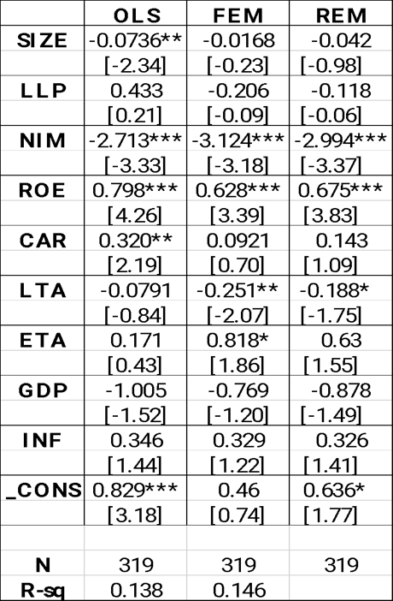

After processing the research data and putting it into the STATA analysis software, the analysis results of F-test:

Table 5. F-test

|  |
| --- |
| F - test that all u_i=0: F(28, 281) = 5.10 |
| Prob > F = 0.0000 |

Given that the STATA analysis findings indicate that P-value = 0.0000 < 0.05, rejecting the null hypothesis H0, suggests that the FEM model is more appropriate.

### **4.3.2.**   **Compare Pooled model – OLS and REM**

After selecting the FEM model from the two Pooled models - OLS and FEM, the two models will be used to determine the suitable Research model for the following phases: OLS and REM. The test hypothesis is:

*H0: The Pooled-OLS model is more suitable for the research variables.*

*H1: The REM model is more suitable for the research variables.*

After processing the research data and putting it into the STATA analysis

software, the analysis results of xttest0:

Table 6. xttest

|  |
| --- |
| Test:   Var(u) = 0 |
| chibar2(01) =   102.38 |
| Prob > chibar2 =   0.0000 |

The REM model is better suitable, according to the STATA analysis results, which show that Prob>chi2 = 0.0000 < 0.05 rejects the null hypothesis H0. Therefore, *The REM model is more suitable.*

### **4.3.3.**  **Compare FEM and REM**

After selecting the FEM model from among the two Pooled models - OLS and FEM and the REM model from among the two Pooled models - OLS and REM. The thesis then employs the Hausman test to compare the Fixed Effects Model (FEM) and Random Effects Model (REM) in order to choose the most sustainable regression model. The test hypothesis is:

*H0: There is no correlation between the independent variables and the residual, which means that the REM model is more suitable.*

*H1: There is a correlation between the independent variables and the residual,*

*which means that the FEM model is more suitable.*

Table 7. Hausman test

|  |
| --- |
| Test:  Ho:  difference in coefficients not systematic |
| chi2(9) = (b-B)'[(V_b-V_B)^(-1)](b-B) = 18.88 |
| Prob > chi2 =  0.0265 |

The findings of the STATA study, which demonstrate that Prob > chi2 = 0.0265< 0.05 rejects the null hypothesis H0, indicate that the FEM model is more appropriate.

### **4.3.4.**  **Check for multicollinearity**

To evaluate the multicollinearity of the research model using the STATA VIF command in order to determine if the research model contains independent variables or not. If the research findings receive a VIF index of less than 10, this indicates that the research model does not contain multicollinearity, and if the research results obtain a VIF index of greater than 10, this indicates that the research model does.

Table 8. Research of multicollinearity test

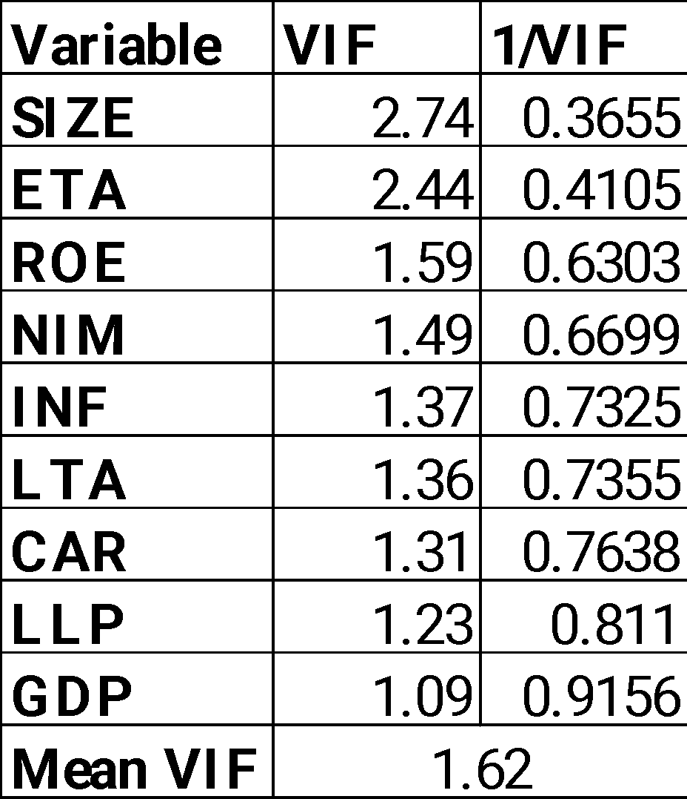

The independent variables all have VIF indices below 10, indicating that there is no multicollinearity, after using the VIF command in the STATA program.

### **4.3.5.**  **Check for autocorrelation**

The goal of the research test is to determine whether the research model exhibits the autocorrelation phenomena by using the Wooldridge Test to verify, the research test hypothesis is posed as:

*H0: The research model does not have autocorrelation.*

*H1: The research model has autocorrelation.*

If the test results show Prob > F > 5%, the research model accepts hypothesis H0, indicating that the research model does not exhibit autocorrelation.

Table 9. Wooldridge test

|  |  |
| --- | --- |
| Wooldridge test for autocorrelation in panel data | |
| H0: no first-order autocorrelation | |
| F(  1, 28) | 12.234 |
| Prob > F | 0.0016 |

After applying Wooldridge Test, the author's research model obtained P-value =

0.0016 < 0.05, the research model rejected the hypothesis H0, meaning that the results of the research model have a phenomenon of autocorrelation.

### **4.3.6.**  **Test for the phenomenon of autocovariance change**

After selecting the FEM model as the most suitable model, the author will test the

phenomenon of autocovariance change through the assumption:

*H0: The model does not have variable variance.*

*H1: The model occurs with variable variance.*

Table 10. Modified Wald test result

|  |  |
| --- | --- |
| Modified Wald test for groupwise heteroskedasticity in fixed effect regression model | |
| H0: sigma (i)^2 = sigma^2 for all i | |
| chi2 (29) | 22065.37 |
| Prob>chi2 | 0.0000 |

After selecting the FEM model over the REM model as a better research model, the author used the test of the phenomenon of variance to achieve the findings Pvalue = 0.000 < 0.05, rejecting the hypothesis H0, indicating that the research model has variable variance phenomena.

### **4.3.7. Check for stationary**

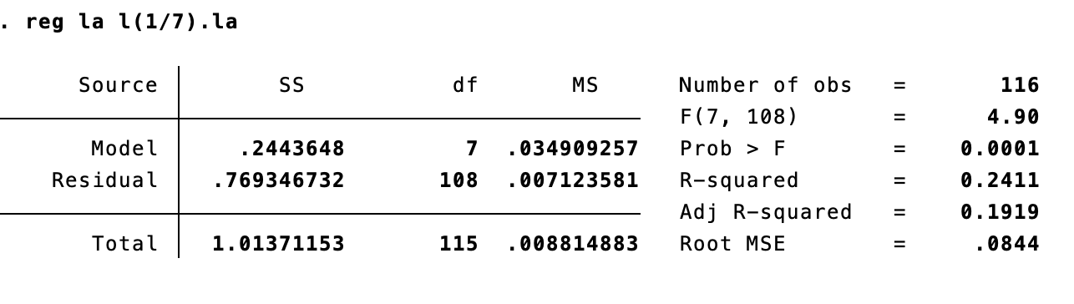

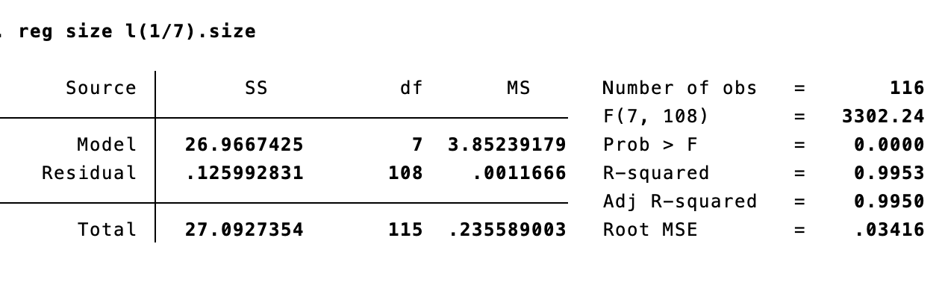

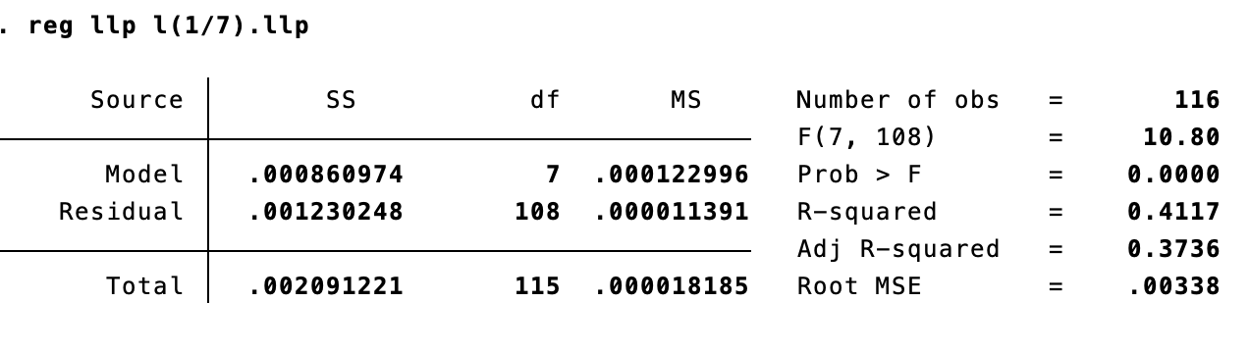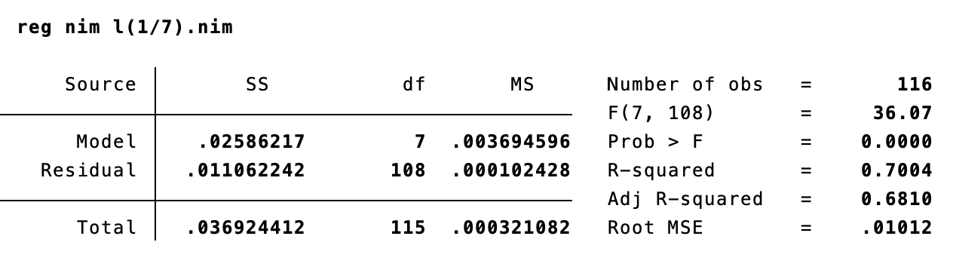

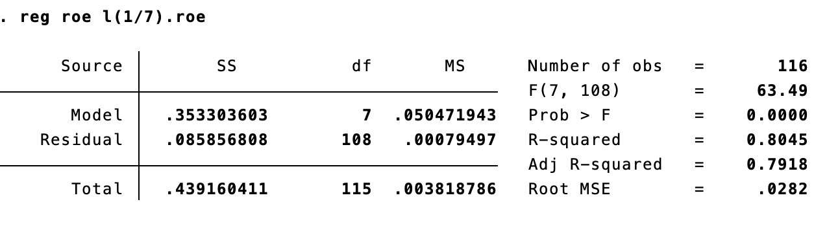

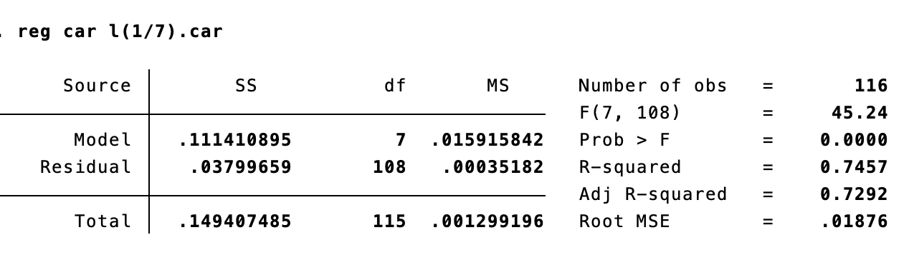

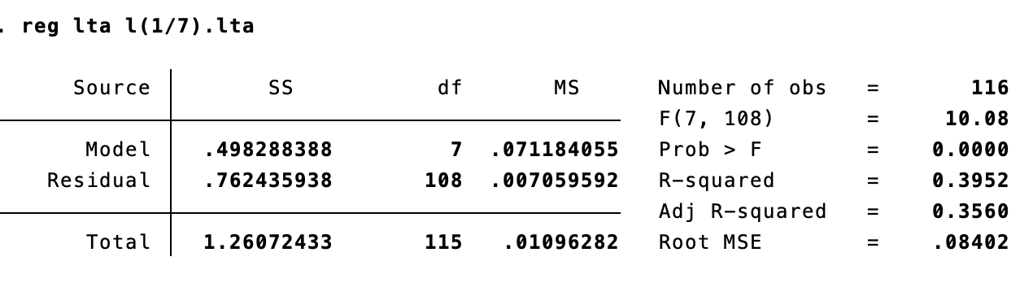

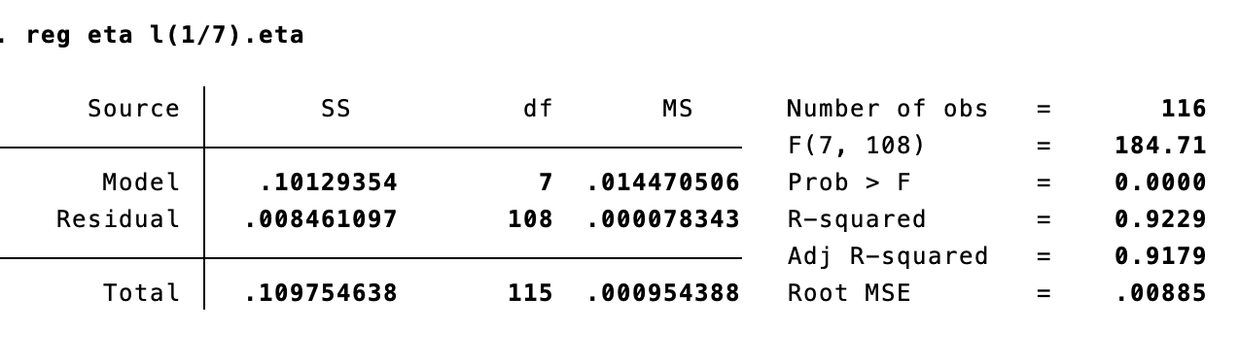

Because all above variables have p_value < 0.05, rejecting the hypothesis H0, indicating that the data is not stationary.

### **4.3.8. Check for heteroskedastic**



Prob = 0.0890 > 0.05. The research model accepts hypothesis H0, indicating that the research model does not heteroskedastic.

## **4.4.**  **Overcoming the research model and GMM regression method**

### **4.4.1.**  **Overcoming the research model**

The FEM model was shown to be the most appropriate through analysis and model testing, yet the research model confronts autocorrelation and variable variance using the Wooldridge and Modified Wald tests. As a result, the author continues to use the feasible generalized least squares model (FGLS) approach in the research model to avoid these two occurrences.

Table 11. Summarize research model included OLS-FEM-REM-FGLS

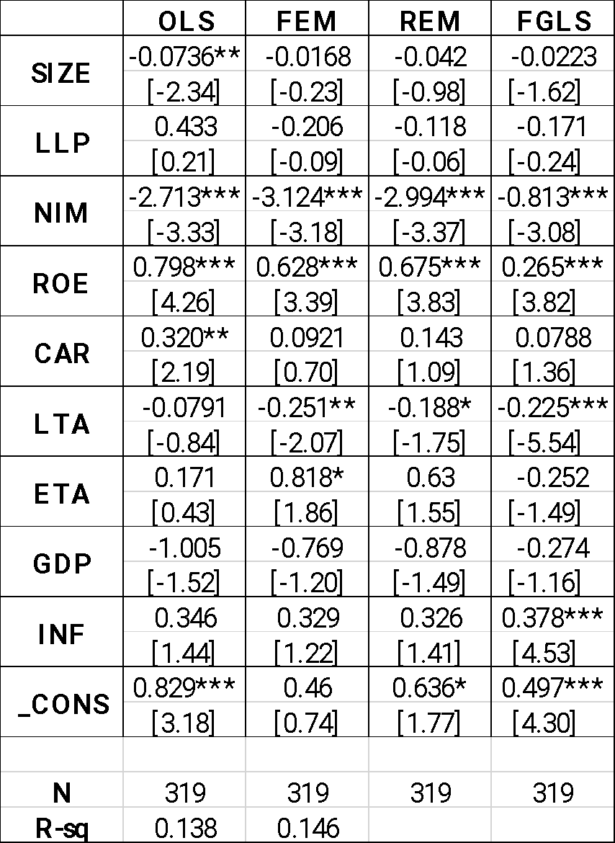

The factors with research significance in the FGLS research model are NIM, ROE, LTA, and INF. While NIM and LTA have a negative influence on LA, the other two variables with statistical significance, ROE and INF, have a positive impact on LA. Furthermore, SIZE, LLP, CAR, ETA, and GDP are not statistically significant in the model.

From the estimated results obtained, the model studies the factors affecting the

liquidity risk of Vietnamese commercial banks in the period 2011 – 2021:

**LA =** **0.497*** - 0.0223SIZE - 0.171 LLP** **- 0.813*** NIM + 0.265***ROE + 0.0788 CAR - 0.225***LTA - 0.252ETA - 0.274GDP +** **0.378***INF +**

● **Dependence on Net interest margin**

Net interest margin has a negative relationship with liquidity risk (LA) at the 1% level of significance,

***Graph 4.1. Relationship between NIM and LA***

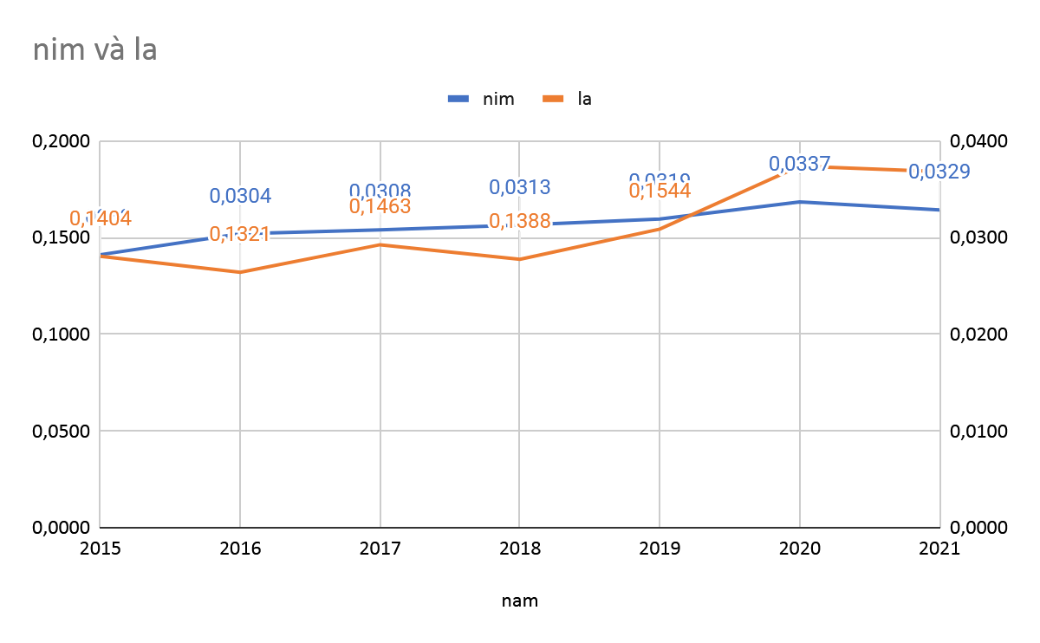

NIM has negative and significant effects on liquidity risk (LA) at the 1% level of significance indicating that for every unit of net interest margin, the bank's liquidity risk decreased by 0.813 units . Banks have good ability in generating net interest income from loans, and it can be used to cover their short term maturity dates so banks can avoid liquidity risk. Its finding is supported by the research of Sharma and Gounder (2012), Harjum Muharam & Hasna Penta Kurnia (2013) that found that NIM has negative influence to liquidity risk

● **Return on equity**

Return on equity (ROE) shows a positive relationship with liquidity risk (LA) with a statistical significance of 1%, according to the research findings, which are similar with other earlier studies:  Mehmed (2014), Ahamed (2021),  Moussa (2015). The research findings contradict the notion proposed by the author, and the link between ROE  and LA is depicted in the chart below:

***Graph 4.2. Relationship between LA and ROE***

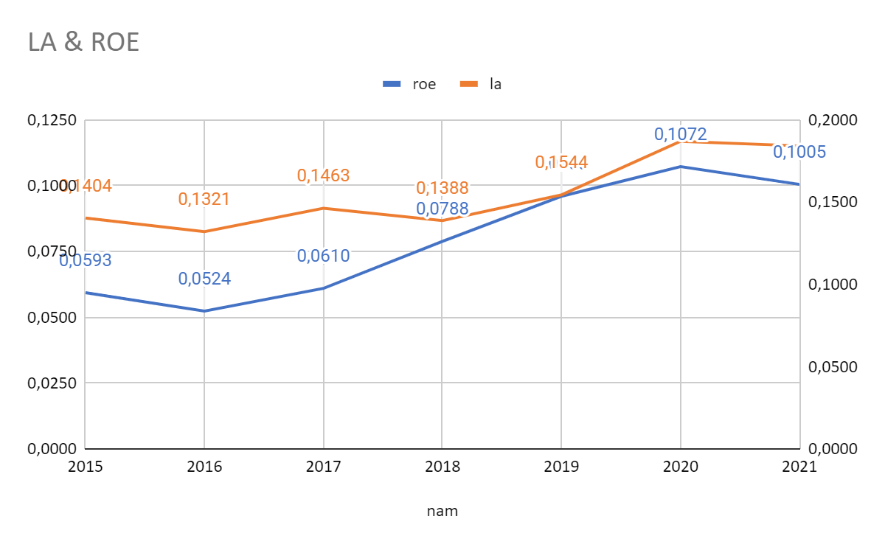

The positive findings between ROE and LA reveal that if the return on equity improves by one unit, the bank's liquidity risk increases to 0.265265 units. When a bank's ROE is higher, it indicates that the bank has efficiently used financial leverage and produced a substantial profit from lending activities. Commercial banks have exchanged liquidity safety for profits; nevertheless, if banks utilize equity to lend and generate profits, it will place the bank in a precarious scenario with high credit risk and poor liquidity due to unstable equity.

● **LTA**

The loan to total asset ratio, or the proportion of total loans in total assets, has a negative impact on a bank's liquidity ratio with a statistical significance of 1% according to the research findings, which are similar with other earlier studies Fentaw Leykun (2016).  If the return on equity improves by one unit, the bank's liquidity risk decreases to 0.225 units.

The loan to total asset ratio-the shares of total loans in total assets of commercial banks affect negatively the liquidity ratio of banks.

***Graph 4.3. Relationship between LA and LTA***

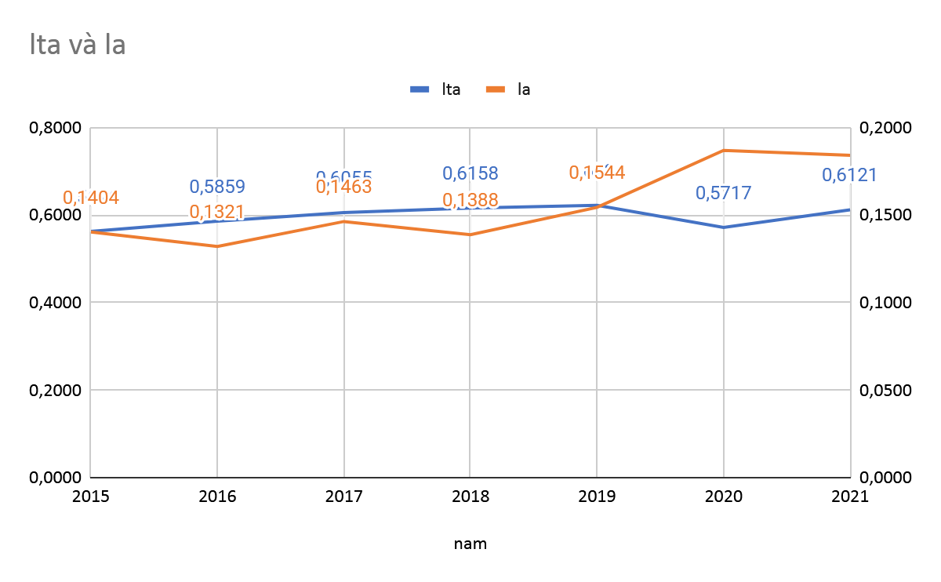

It is a measure of the illiquidity of the asset portfolio that can reflect excessive illiquidity and higher exposure to default risk (Arena, 2005). The higher the ratio, the more illiquid an institution is considered. It measures the share of loans in total assets. It indicates what percentage of the assets of the bank is tied up in illiquid loans. Therefore the higher this ratio the less liquid the bank is. It is inferred that, since loans are illiquid assets, increase in the amount of loans means increase in illiquid assets in the asset portfolio of a bank. According to Eakins (2008), in practice the amount of liquidity held by banks is heavily influenced by loan demand that is the base for loan growth. If demand for loans is weak, then the bank tends to hold more liquid assets (short term assets), whereas if demand for loans is high they tend to hold less liquid assets since long term loans are generally more profitable.

● **Inflation**

The inflation rate (INF) has a positive relationship with bank liquidity risk with a statistical significance level of 1%, the results of this study are consistent with the research hypothesis set by the author. The results are consistent with previous studies:Hạnh and Vy (2019), Moussa (2015), Shen, Chen, Kao, and Yeh (2009), and Vodova45 (2011). The positive results between INF and LA show that if the inflation rate increases by 1 unit, the bank's liquidity risk increases by 0.378378 units with a statistical significance of 1%.

***Graph 4.4. Relationship between LA and INF***

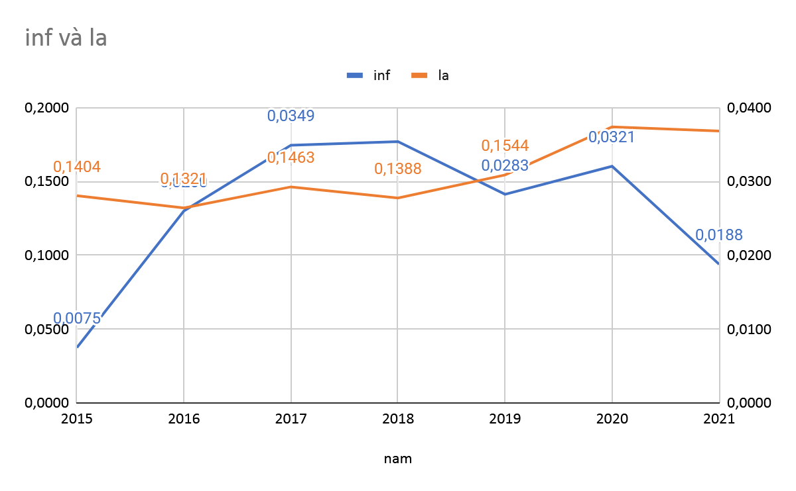

When the inflation rate increases, it means that the value of the local currency is lost, and the bank's investments will be reduced in value, so the profits that the bank earns are not high. Next, borrowers will easily pay back their loans because the loan value will be lower, and customers will deposit fewer savings in the bank because at this time the deposit interest rate will also decrease, so in this case increased the bank's liquidity risk.

### **4.4.2. GMM Regression Model Method**

Table 12. GMM Regression Model

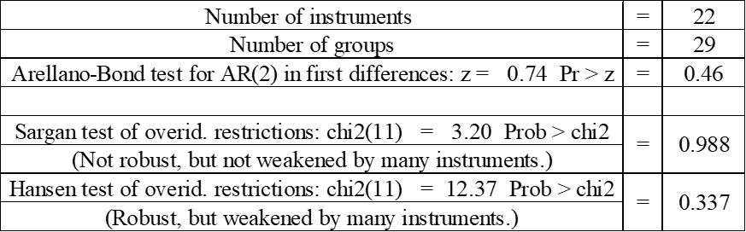

The Arellano-Bond test P-value is 0.46 , and anything above 0.1 indicates that the model does not have an autonomic phenomenon chain association. The GMM regression model demonstrates that the number of tools does not exceed the number of research groups (22<29). The Sargan test's P-value is 0.988, indicating that the instrumental variable is appropriate and an endogenous phenomena exists. The Hansen test results in a P-value of 0.337, demonstrating the suitability of the model's tools. These four criteria were satisfied by the GMM regression model, demonstrating its applicability, effectiveness, and high accuracy.

The results from the GMM approach are more thorough because the GMM regression equation produces different results from those from the FGLS method once endogeneity in the study model has been taken into account. The following equation illustrates the GMM regression approach that was used as a conclusion in the thesis to examine the variables influencing the liquidity risk of Vietnamese commercial banks between 2011 and 2021:

**LA =** **1.714\*\*\*** + **0.22L.LA - 0.179***SIZE + 3.607** LLP** + **1.304NIM + 1.210***ROE  - 0.165CAR - 0.258LTA -1.205ETA - 0.858** GDP +** **0.506** **INF +**

### **4.4.3.**  **Summarize and discuss research result**

After performing data processing steps and performing analysis through STATA software, the author obtained the results of 5 research models. In which, the GMM regression method is used to conduct endogenous control. The results collected from the 5 research models are summarized and presented in the following table:

Table 13. Summarize 5 research

model 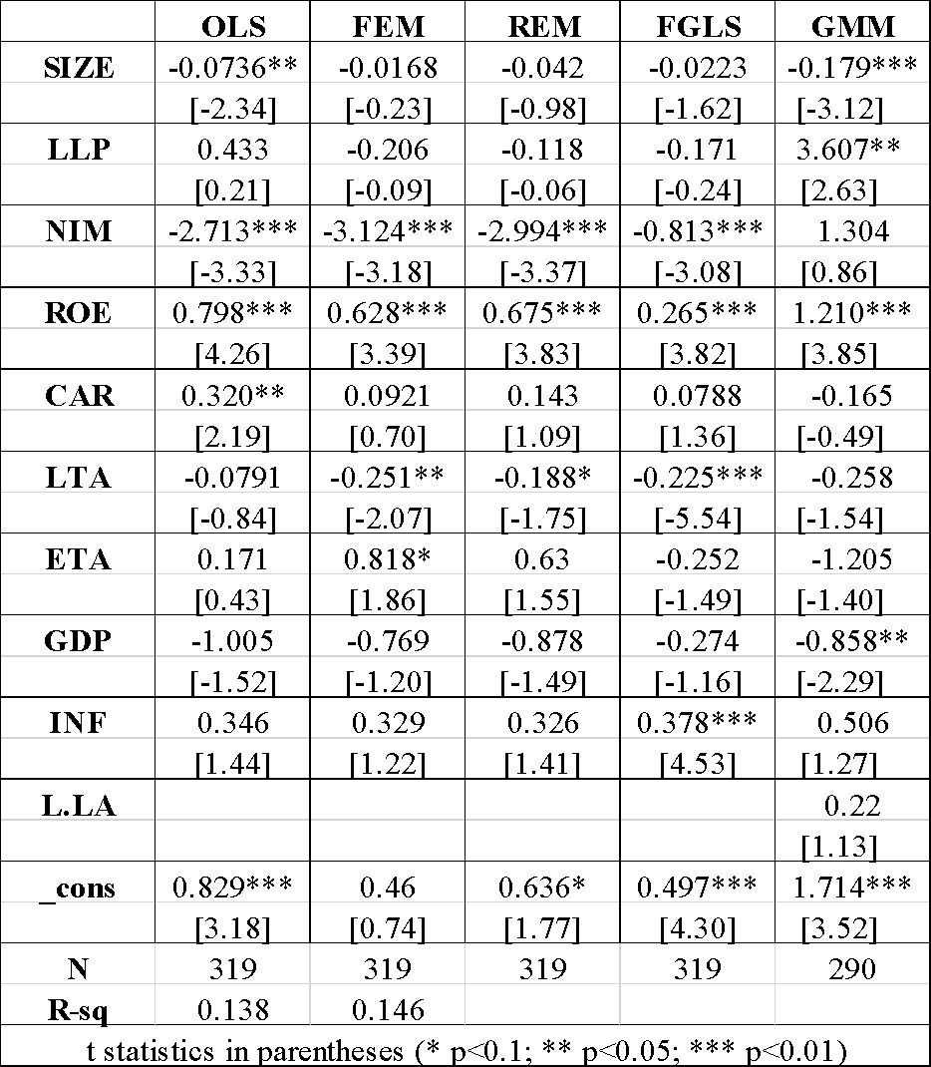

● **Dependence on the asset size of bank (SIZE)**

Bank size (SIZE) has a negative relationship to liquidity risk (LA) at the 1% level of significance, the research results are consistent with some previous studies: Negash  (2019), Ahamed (2021), Suleiman et al. (2021),  Hao et al. (2021), El-Chaarani (2019), Alzoubi (2017). The research results are consistent with the hypothesis that the author has set, the relationship between SIZE and LA is shown in the chart below:

***Graph 4.5. Relationship between LA and SIZE***

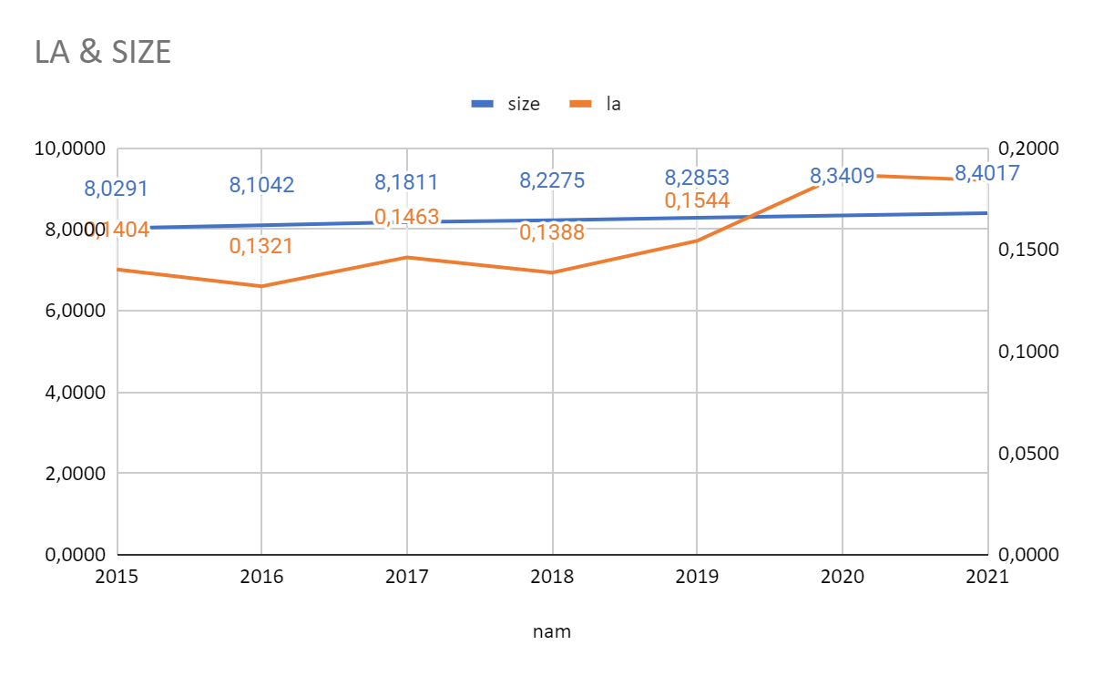

This unfavorable outcome demonstrates how a tiny bank size will harm the bank's liquidity at this time. The liquidity risk falls by 0.179 units for every unit increase in bank size. According to the analysis's findings, banks' trustworthiness and dependability increase with size between 2011 and 2021, making it simpler for them to get money from a variety of sources. Since the difference increases overall bank assets, the liquidity reserve is always guaranteed, lowering the danger of running out of cash. Customers will prefer and trust utilizing products and services from larger banks, making it difficult for smaller banks to compete with them.

● **Loan loss provision**

Loan loss provision has a positive relationship with liquidity risk (LA) at the 5% level of significance,at the 1% level of significance, the research findings are in agreement with several earlier studies: Nguyen (2022), Tran et al. (2019), Mamunur Rashid et al. (2017), Ganic (2014). The research findings support the author's premise, and the link between LLP and LA is depicted in the chart below:

***Graph 4.6. Relationship between LA and LLP***

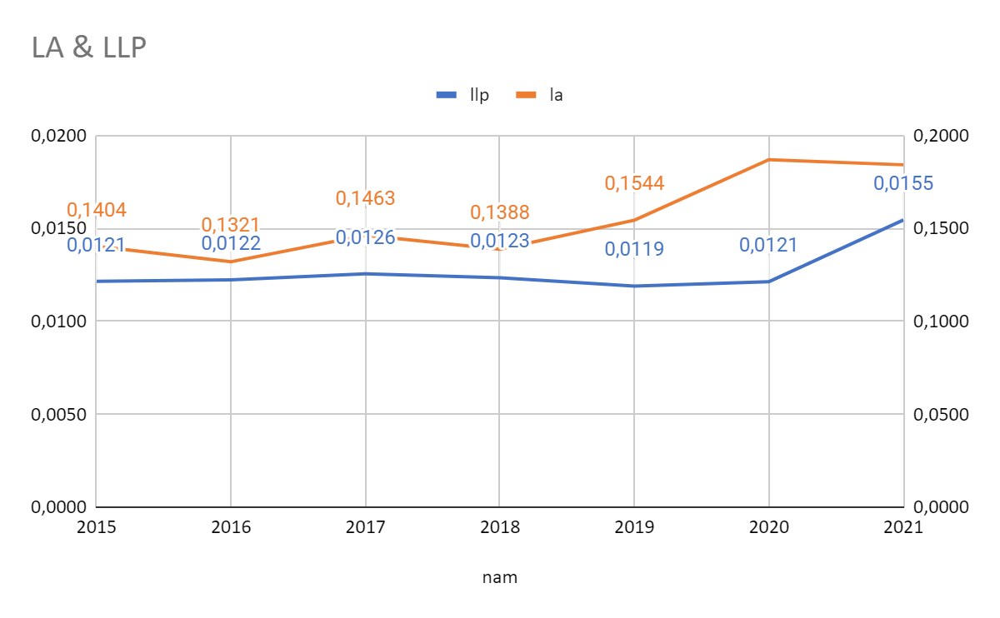

The ratio of loan-loss provisions to total loans is the proxy utilized for this variable. It serves as a gauge for both bank credit quality and capital risk. Banks would likely have a larger loan-loss provision ratio to account for this risk if they operate in riskier locations and lack the skills to manage their lending operations. The liquidity risk increase by 3.607 units for every unit increase in loan loss provision. Therefore, the greater the loan loss provision, the greater the risk to liquidity.

● **Economic growth rate**

Economic growth rate (GDP) has a 5% statistically significant negative association with bank liquidity risk. The research findings do not support the author's research premise; however, the findings do support the following studies:  Mehmed (2014) ,  Incekara & Cetinkaya (2019),Tasnova (2022)*.* The graphic below depicts the link between GDP and LA:

***Graph 4.7. Relationship between LA and GDP***

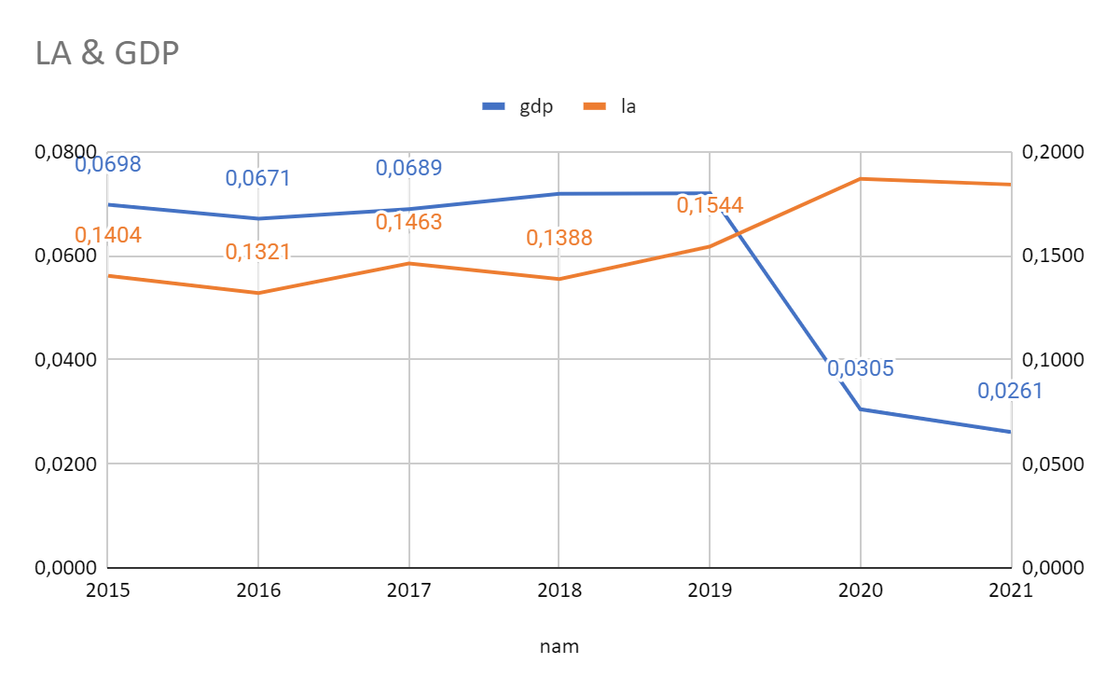

The negative correlations between GDP and LA show that the bank's liquidity risk decreases to 0,858 units if the gross domestic product increases by one unit.

# **CHAPTER 5.**      **CONCLUSION, RECOMMENDATION AND LIMITATION OF RESEARCH MODEL**

## **5.1.**  **Conclusion**

Data is processed and analyzed using STATA software based on a data table containing 319 observations of 28 Vietnamese commercial banks throughout the course of the years 2011 to 2021. In order to provide the best and most trustworthy research findings, the research results are given in the form of descriptive statistical analysis, correlation analysis, estimate techniques like Pooled-OLS, FEM, REM, FGLS regression model approach, and notably the GMM method. The thesis has generated study findings concluding elements impacting the liquidity risk of Vietnamese banks between 2011 and 2021 after experiencing estimating and testing methodologies.

LLP and ROE are variables that have positive impact on liquidity risk (LA) while GDP and SIZE have a negative impact on LA. The remaining variables are not statistically significant in the model.

## **5.2.**  **Recommendation**

The research results show that the problem of bad debt and credit risk provision plays a very important role, having a strong influence on the liquidity of Vietnamese joint stock commercial banks. Therefore, banks need to focus on strengthening risk management capabilities in line with the constantly increasing scale over time; strengthen internal supervision to prevent future generation and accumulation of bad debts, by ensuring that banks avoid excessive lending and maintain adequate credit standards to ensure quality loan amount. Joint Stock Commercial Banks of Vietnam need to develop a long-term strategy from remote bad debt prevention measures such as perfecting credit policies in line with international standards as a prerequisite to ensure consistent application of credit policies and tightness in the bank. In addition, departments in the bank need to focus on performing well their functions and duties in terms of risk identification, control and mitigation. At the same time, make full provision for credit risk and the classification of debts in accordance with the nature of the debt to provide specific solutions to deal with problems when those debts arise, thereby having more effective management. When adequate provisions are made, it will be easier to handle debts and avoid affecting the bank's profits and liquidity. Vietnamese joint stock commercial banks need to take advantage of bank size to minimize the reserve of assets with high liquidity but low profitability to invest in business activities that bring high profits. In addition, when conducting scale expansion, banks need to carefully consider and pay special attention to human resources along with management capacity to avoid focusing only on expanding their operating network. while human resources are limited. Finally, in order to improve liquidity, banks may consider using deposit interest rates to increase capital mobilized from customer deposits, especially medium and long-term capital to always meet the needs of customers. promptly withdraw money from the bank at a reasonable cost.

## **5.3.**  **Limitation**

There are 31 banks in the commercial banking system of Vietnam, but only 28 of them have complete data from 2011 to 2021; the other banks began operations after 2011, so there are no earlier data; the most recent data have not been formally published by commercial banks on their websites; there was data loss in the middle of the research period; etc.

There are still a lot of elements occurring within and outside the bank that cannot be quantified because the author had a limited amount of time for study and had problems gathering data and research material. The study subject is constrained by the fact that the authors cannot be incorporated into the research model.

To be able to forecast the trajectory of some influences on liquidity risk in each period, each distinct era, the study subject must broaden the time range. Additionally, in order to have a more comprehensive understanding of the whole Vietnamese banking system, additional study data on commercial banks that are not addressed in this research thesis must be gathered. To have a more complete view of the research factors impacting the bank's liquidity risk, the research subject also needs to include additional micro and macro research variables. timely predictions and action taken to reduce liquidity concerns in the Vietnamese banking system

# **REFERENCES**

1) Abdullah, A., & Khan, A. Q. (2012). Liquidity risk management: a comparative study between domestic and foreign banks in Pakistan. Journal of ManagerialSciences Volume VI Number, 1, 62.

2) Abdulhakim, D. İ. K. O. (2019). Determinants of Net Interest Margins in Turkish Banking System: A Panel Data Analysis. Maliye ve Finans Yazıları, (111), 233-266.

3) Abor, J., 2005. The Effect of Capital Structure on Profitability: An Empirical Analysis of Listed Firms in Ghana. Journal of Risk Finance, 6(5): 438- 445.

4) Abdelaziz, H., Rim, B., & Helmi, H. (2022). The interactional relationships between credit risk, liquidity risk and bank profitability in MENA region. Global Business Review, 23(3), 561-583

5) Alzorqan, S.T., 2014. Bank Liquidity Risk and Performance: An Empirical Study of the Banking System in Jordan. Research Journal of Finance and Accounting, 5(12): 155-164.

6) Amara, T., & Najar, T. (2021). The effect of liquidity risk on bank performance: A comparative study of Islamic and conventional banks in the middle east and north Africa region. Accounting, 7(5), 1211-1220.

7) Arif, A., & Nauman Anees, A. (2012). Liquidity risk and performance of banking system.Journal of Financial Regulation and Compliance, 20 (2), 182-195.

8) Aspachs, O., Nier, E. W., & Tiesset, M. (2005). Liquidity, banking regulation and the macroeconomy. Available at SSRN 673883.

9) Ayaydin, H., & Karakaya, A. (2014). The effect of bank capital on profitability and risk in Turkish banking. International Journal of Business and Social Science,5 (1).

10) Barth, J.R., D.E. Nolle, T. Phumiwasana and G. Yago, 2003. A Cross-Country Analysis of the Bank Supervisory Framework and Bank Performance. Financial Markets, Institutions and Instruments, 12: 67-120.

11) Bourke, P., 1989. Concentration and Other Determinants of Bank Profitability in Europe, North America and Australia. Journal of Banking and Finance, 13(1): 65-79.

12) Berger, A.N., 1995. The Relationship Between Capitals and Earnings in Banking. Journal of Money, Credit and Banking, 27(2): 432-456.

13) Bonfim, D. & Kim M, Liquidity risk in banking: is there herding? International Economic Journal, 22(3), (2011), 361-386

14) Bonin, P., Hasan, I. & Wachtel, P. (2004), ‘Privatization matters: Banking efficiency in transition countries’, Discussion Paper 8/2004, BOFIT, Finland.

15) Bunda, T. & Desquilbet, J.B., 2008. The Bank Liquidity Smile Across Exchange Rate Regimes, International Economic Journal, Vol 22(3), 361-386.

16) Bryant, j. 1980. A model of reserves, bank runs, and deposit insurance. Journal of Banking and Finance 4, 335-344;

17) Chen, Y. K., Shen, C. H., Kao, L., & Yeh, C. Y. (2018). Bank liquidity risk and performance. Review of Pacific Basin Financial Markets and Policies, 21(01), 1850007.

18)  Chowdhury, A. M. H., Siddiqua, A., & Chowdhury, A. S. M. M. H. (2016). Relationship between liquidity risk and net interest margin of conventional banks in Bangladesh. Asian Business Review, 6(3), 175-178

19) Chung-Hua-Shen, Chen, Y. K., Kao, L. F. & Yeh C. Y., 2009. Bank Liquidity Risk and Performance. Department of Finance: National Taiwan University.

20) Cucinelli, D. (2013). The determinants of bank liquidity risk within the context of euro area. Interdisciplinary Journal of Research in Business, 2 (10), 51-64.

21) Delécha, C., Henao, C., Muthoora, P., & Vtyurina, S. (2012). The Determinants of Banks' Liquidity Buffers in Central America.

22) Demirguc-Kunt, A., R. Levine and H.G. Min, 1998. Opening to Foreign Banks: Issues of Stability, Efficiency and Growth. In S. Lee., The Implications of Globalization of World Financial Markets. Seoul: Bank of Korea.

23) Diamond, D.W and R.G, Rajan., 2005. Liquidity Shortages and Banking Crises. The Journal of Finance, 60(2): 614-647.

24)  Dinger, V. (2009). Do foreign-owned banks affect banking system liquidity risk? Journal of Comparative Economics, 37 (4), 647-657.

25)  Duttweiler, R., 2009. The Meaning of Liquidity Risk. John Wiley & Sons. Chapter, 1: 10-11.

26)  EfJaara, K. A., & Disman, D. (2017). Liquidity Risk: Comparison between Islamic and Conventional Banking. European Research Studies, 20(2), 308-318.

27)  Falconer, B., 2001. Structural Liquidity: The Worry Beneath the Surface. Balance Sheet, 9(3): 13- 19.

28)  Ferrouhi, E. M. (2014). BANK LIQUIDITY AND  FINANCIAL PERFORMANCE: EVIDENCE FROM MOROCCAN BANKING INDUSTRY. Business: Theory & Practice,15 (4).

29)  Ferrouhi, E., & Lahadiri, A. (2014) Liquidity Determinants of Moroccan Banking Industry. International Research Journal of Finance and Economics, 118, 103-112.

30)  Gatev, E. & Strahan, P. E. 2006. Banks’ Advantage in Hedging Liquidity Risk: Theory and Evidence from the Commercial Paper Market. The journal of finance. Vol 2.

31)  Giannotti C., Gibilaro L. & Mattarocci G. (2010). Liquidity Risk Exposure for specialised and Unspecialized Real Estate Banks: Evidence from the Italian market. Journal of Property Investment and Finance, 29(2), 98-114.

32)  Ganic, M. (2014). An Empirical Study on Liquidity Risk and its determinants in Bosnia and Herzegovina. The Romanian Economic Journal, Year XVII no, 52.

33)  Ha, D. T., Hang, H. T. T., Huy, T. T., & Phung, N. T. K. (2022). FACTORS AFFECTING LIQUIDITY OF COMMERCIAL BANKS IN VIETNAM. Proceedings on Engineering, 4(2), 115-124.

34)  Hang, P. T. N., Thai, H. H., & Giang, N. T. T. (2021). THE IMPACT OF TECHNOLOGY INVESTMENT TO LIQUIDITY RISK OF COMMERCIAL BANKS IN VIETNAM. Academy of Strategic Management Journal, 20, 1-10.

35) Hashim, N. N., Abdul-Rahman, A., & Amin, S. I. M. Output Efficiency and Liquidity Risk of Islamic Banks. Turkish Journal of Islamic Economics, 9(2), 25-47.

36)  Huong, T. T. X., Nga, T. T. T., & Oanh, T. T. K. (2021). Liquidity risk and bank performance in Southeast Asian countries: a dynamic panel approach. Quantitative Finance and Economics, 5(1), 111-133.

37)  İncekara, A., & Çetinkaya, H. (2019). Liquidity Risk Management: A Comparative Analysis of Panel Data Between Islamic and Conventional Banking in Turkey. Procedia Computer Science, 158, 955-963.

38)  Jaara, O. O., Jaara, B. O., Shamieh, J., & Fendi, U. A. (2017). Liquidity risk exposure in Islamic and Conventional banks. International Journal of Economics and Financial Issues, 7(6), 16.

39)  Kosmidou, K., S. Tanna and F. Pasiouras, 2008. Determinants of Profitability of Domestic UK Commercial Banks: Panel Evidence from the Period 1995-2202. Economics, Finance and Accounting Applied Research Working Paper Series, pp: 1-27.

40)  Lucchetta, M. (2007). What do data say about monetary policy, bank liquidity and bank risk taking? Economic Notes, 36 (2), 189-203.

41)  Marozva, G. (2015). Liquidity and bank performance. International Business & Economics Research Journal (IBER), 14(3), 453-562

42)  Mennawi, A. N. A., & Ahmed, A. A. (2020). The Determinants of Liquidity Risk in Islamic Banks: A Case of Sudanese Banking Sector. International Journal of Islamic Banking and Finance Research, 4(1), 38-49.

43) Mehmed, G. (2014). An Empirical Study on Liquidity risk and its determinants in Bosnia and Herzegovina. The Romanian Economic Journal(52), 157 - 184.

44)  Molyneux, P. and J. Thornton, 1992. Determinants of European Bank Profitability: A Note. Journal of Banking and Finance, 16: 1173- 1178.

45)  Munteanu, I. (2012). Bank liquidity and its determinants in Romania. Procedia Economics and Finance, 3, 993-998.

46)  Moussa, M. (2015). The determinants of bank liquidity: Case of Tunisia. International Journal of Economics and Financial Issues, 5(1), 249-259.

47)  Naceur, S. B., and Kandil, M. (2009), “The Impact of Capital Requirements on Banks' Cost of Intermediation and Performance: The Case of Egypt,” Journal of Economics and Business,  Vol. 61, 70-89

48)  Negash, D. W., & Veni, P. (2019). Determinants of liquidity risk in selected commercial banks in ethiopia. International Journal of Advanced Research in Management and Social Sciences, 8(4), 108-124.

49)  Nguyen, H. C. (2022). Factors Affecting Liquidity Risks of Joint Stock Commercial Banks in Vietnam. The Journal of Asian Finance, Economics and Business, 9(4), 197-212.

50)  Tasnova, N. (2022). Impact of Bank Specific and Macroeconomic Determinants on Banks Liquidity: An Empirical Study on Listed Commercial Banks in Bangladesh. Finance & Economics Review, 4(1), 11-24.

51)  Thuận , N. T., & Tuyết , P. Á. (2021, 04). Nhân tố ảnh hưởng đến rủi ro thanh khoản tại các ngân hàng thương mại Việt Nam. Tạp chí Công Thương - Các kết quả nghiên cứu khoa học và ứng dụng công nghệ, 9.

52)  THÔNG, T. Q. (2013). Factors affecting liquidity risk in the system of Vietnamese commercial Banks. Economics Article, University of Economics HCMC.

53)  Tesfaye, T. (2012). Determinants of Banks Liquidity and their Impact on Financial Performance: empirical study on commercial banks in Ethiopia. Advances in Management & Applied Economics, 3(6)

54)  Trương Quang Thông (2013), “Các nhân tố tác động đến rủi ro thanh khoản của các ngân hàng thương mại Việt Nam”, Tạp chí Phát triển kinh tế, số 276, 50-62.

55)  Rauch, C., Hackethal, A., Steffen, S., & Tyrell, M. (2010). Determinants of bank liquidity creation Working paper.

56)  Saunders, A., and Cornett, M. M. (2007), Financial Markets and Institutions: An Introduction to the Risk Management Approach, McGraw-Hill, Boston.

57)  Singh, A., & Sharma, A. K. (2016). An empirical analysis of macroeconomic and bank-specific factors affecting liquidity of Indian banks. Future Business Journal, 2(1), 40-53.

58)  Sopan, J., & Dutta, A. (2018). Determinants of liquidity risk in Indian Bank: A panel data analysis. Asian Journal of Research in Banking and Finance.

59)  Vodová, P. (2011). Determinants of commercial banks' liquidity in the Czech Republic. ratio, 50(3).

60)  Vodova, P. (2011). Liquidity of Czech commercial banks and its determinants. International Journal of mathematical models and methods in applied sciences, 5(6), 1060-1067.

61)  Williams, B. (2014). Bank risk and national governance in Asia. Journal of Banking & Finance, 49, 10-26.

62)  Zheng, H. and Y. Shen, 2008. Jump Liquidity Risk and Its Impact on CvaR. The Journal of Risk Finance, 9(5): 477-491.